**INTI International College Penang School of Engineering and Technology**

**3+0 Bachelor of Science (Hons) in Computing, in collaboration with Coventry University, UK**

**Coursework cover sheet**

**Section A - To be completed by the student**

|  |  |
| --- | --- |
| Full Name: CHAI YI BING | |
| CU Student ID Number: P21013721 | |
| Semester:3 | |
| Session:**April 2022** | |
| Lecturer:  **Nadhrah Abdul Hadi (nadhrah.abdulhadi@newinti.edu.my)** | |
| Module Code and Title:  **4067CEM Software Design** | |
| Assignment No. / Title:  **Continuous Assessment** | % of Module Mark:  **50** |
| Hand out Date:  **22nd April 2022** | Due Date:  **Task 1: 13 May 2022, by 11.59pm**  **Task 2: 1 July 2022, by 11.59pm**  **Task 3: 17 June 2022, by 11.59pm.**  **Task 4: 17 June 2022, by 11.59pm.**  **Task 5: 17 June 2022, by 11.59pm.** |
| Penalties: No late work will be accepted. If you are unable to submit coursework on time due to extenuating circumstances, you may be eligible for an extension. Please consult the lecturer. | |
| Declaration: I/we the undersigned confirm that I/we have read and agree to abide by the University regulations on plagiarism and cheating and Faculty coursework policies and procedures. I/we confirm that this piece of work is my/our own. I/we consent to appropriate storage of our work for plagiarism checking.  Signature(s): ________Bing________________ | |

**Section B - To be completed by the module leader**

|  |  |  |
| --- | --- | --- |
| Intended learning outcomes assessed by this work:  1. Understand and apply appropriate concepts, tools and techniques to each stage of the software development  2. Understand and apply design patterns to software components in developing new software  3. Demonstrate an understanding of project planning and working to agreed deadlines, along with professional, interpersonal skills and effective communication required for software production  5. Demonstrate an awareness of, and ability to apply, social, professional, legal and ethical standards as documented in relevant laws and professional codes of conduct such as that of the Malaysian National Computer Confederation. | | |
| Marking scheme | Max | Mark |
| 1. User Story Mapping 2. Setting up a GitHub Repository 3. Creating a Class diagram and design pattern selection 4. Creating a Prototype User Interface and Usability Testing 5. Discuss the ethical issue related to the software | 20  10  30  20  20 |  |
| Total | 100 |  |

**Class Diagram Draft 1**

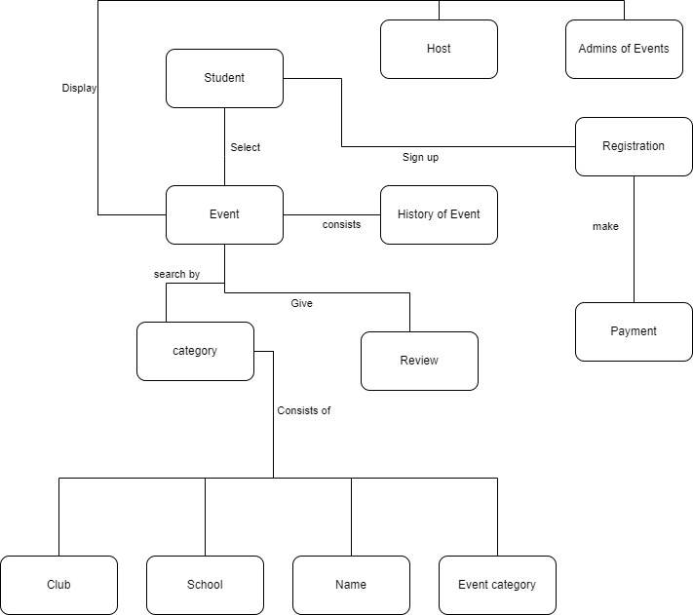

From this Diagram draft :What could we see?

1. The flow of the system
2. The relation of each classes

There is a total of 3 classes in this diagram which is Student, Event and Registration. First of all, Student is the users of this class booking system so Student is the first classes inside the diagram that act as indicator or known as the head of association which links from Student to Event. From that association it will give additional information about the attribute including the flow of the system. So, back to the association of Students and Events. This association would link up Student browsing through a list of events and picking their interest so that they can see the attributes of the event which are history of event, search by category, list of admins, host, reviews and detail of events. Next up would be Event and registration association. This association is a compulsory because without this link Student will not be able to know which event are they signing up for. Other than that, this will also indicate the database to show the cost of a particular event that has been selected by Student. After registration, the system would proceed to payment where Student can select payment method and check the registration fee including paying the registration fee.

**Class Diagram**

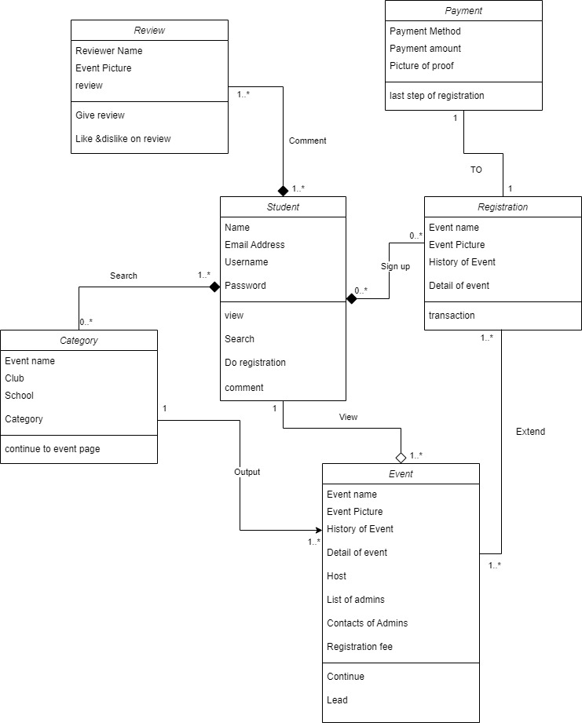

From this actual class diagram, the relationship between each entity and attributes is shown. Therefore, our first entities or known as class is Student which include attributes Name, Email address, Username, Password. From Student, there is a total of four link which is relationship that has been shown by diagram above the relationship between this link also called operations which is view, search, sign up (do registration), and comment. First relationship is between Student and event. In this relationship it will be under the operations view which meant that Student is enable to view the Event page and under Event there is attributes of Event name, Event picture, History of Event, Detail of Event, Host, Lists of admins, Contacts of admins and registration fee. Furthermore, there is an Aggregation relationship between Student and Event. This is due to Event page can exist even without Student. Just to specific Event is a page where it shown out all Event detail which is not a compulsory to be whether view or not view by the Student. Continuing in our relationship of Student and Event, there is a ratio which is called multiplicity. From the relationship, diagram show that one Student are allowed to view one or many Event. This explain that one student could view various event page.

Next relationship would be Student and category, in this relationship can be explain by student search by category and inside category class there is four attributes which are Event name, club, school and category. One or many Student can search zero to many category. From this statement, one or many Students can search or don’t use this function to search by category or search many category. Moreover, there is another relationship between category and event. This relationship is category continue to event after being search by the student. It is due to in category only show a list of events by filtering via the search option of student and after student select an event from the search it would link back to event page which is under event. In addition the multiplicity of category to event is one category to one or many this is due to one category would show a list of event which meant many event page can be access through category. Also, there is a composition between student and category because without student use this function of search by category there will be no existing needs for category.

On top of that, there is another relationship between Student and Registration are also composition. Zero or many Student sign up for zero or many registration. From this statement it shows that if there is no student that sign up for the event there will be zero registration which lead to no exist of registration which is where the composition kick in. Additionally, registration had an operation named as transaction because there is a relationship between registration and payment. Registration to Payment is for the student or user to pay for registration fee and the multiplicity of registration to payment is one to one in either way.

Last relationship in this diagram Student and review. Student is able to comment to review, the multiplicity is one or many Student to one or many review. This statement explain that one student can view or comment one or many review and one or many review can be post by same student or many. Inside Review attributes are Reviewer name, Event picture and review. Inside the Review there will be two operations which is comment and like& dislike.

**Design Pattern**

The design pattern that I choose is mediator. The mediator in UML design pattern defines an object that controls how a set of object interact. I choose this design pattern is due to from my class diagram there is clearly Student act as the object that controls Registration, Review and Category. Without Student all three entities would mean nothing.